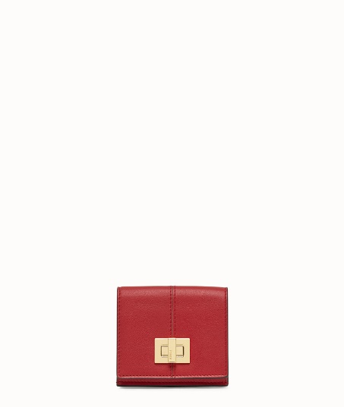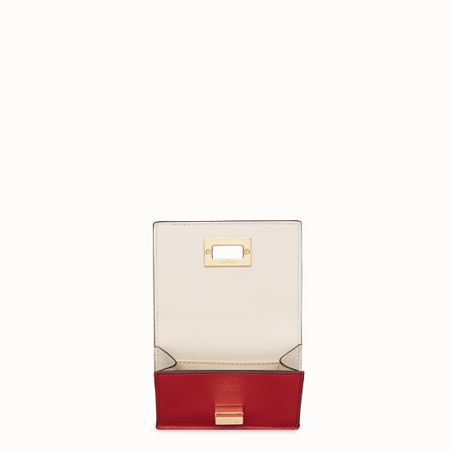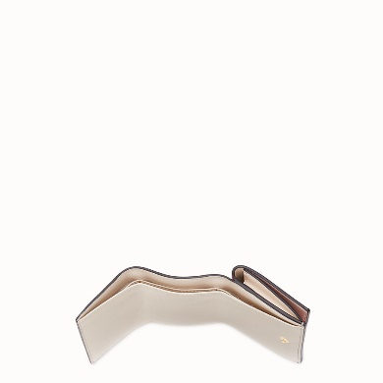FENDI-MICRO TRIFOLD

$650.00

COLOR :COLOR : BLACK/RED

SIZE : ONE SIZE

IN STOCK

##### [Detail](http://127.0.0.1:49618/content/t111N4OiRbh2yVfRAAAB/ABAfZ6j/K0ufyXX/fRVLCpu/tpHA25c/eROJrEC/ogVGDEa#collapse)

Compact, tri-fold Peekaboo wallet with large internal bill compartment and three concealed card holders. External purse with iconic hook closure. Made of matte-effect red calf leather. Contrasting two-tone lining. Gold-finish metalware. Made in Italy.

• Length:2.8 inches

• Height:3.7 inches

• Depth:1.2 inches

• Composition:100% Calfskin

Universal Style #: Product Code:8M0415A5DYF0MVV

[CARE & COMPOSITION](http://127.0.0.1:49618/content/t111N4OiRbh2yVfRAAAB/ABAfZ6j/K0ufyXX/fRVLCpu/tpHA25c/eROJrEC/ogVGDEa#collapse1)

• Leather

• Imported